…a lender must make the same costly investments as a purchaser in

order to make sure that the property is under the borrower’s control

and that, in the event of a default, the property can be obtained with the

same rights as those enjoyed by the present owner. This increases the

interest rate charged by lenders for loans guaranteed by an expectative

property right or its equivalent; worse still, it may simply prevent such

transactions from taking place” (de Soto 1989, 162).

…a lender must make the same costly investments as a purchaser in

order to make sure that the property is under the borrower’s control

and that, in the event of a default, the property can be obtained with the

same rights as those enjoyed by the present owner. This increases the

interest rate charged by lenders for loans guaranteed by an expectative

property right or its equivalent; worse still, it may simply prevent such

transactions from taking place” (de Soto 1989, 162).

…a lender must make the same costly investments as a purchaser in

order to make sure that the property is under the borrower’s control

and that, in the event of a default, the property can be obtained with the

same rights as those enjoyed by the present owner. This increases the

interest rate charged by lenders for loans guaranteed by an expectative

property right or its equivalent; worse still, it may simply prevent such

transactions from taking place” (de Soto 1989, 162).

…a lender must make the same costly investments as a purchaser in

order to make sure that the property is under the borrower’s control

and that, in the event of a default, the property can be obtained with the

same rights as those enjoyed by the present owner. This increases the

interest rate charged by lenders for loans guaranteed by an expectative

property right or its equivalent; worse still, it may simply prevent such

transactions from taking place” (de Soto 1989, 162).

…a lender must make the same costly investments as a purchaser in

order to make sure that the property is under the borrower’s control

and that, in the event of a default, the property can be obtained with the

same rights as those enjoyed by the present owner. This increases the

interest rate charged by lenders for loans guaranteed by an expectative

property right or its equivalent; worse still, it may simply prevent such

transactions from taking place” (de Soto 1989, 162).

…a lender must make the same costly investments as a purchaser in

order to make sure that the property is under the borrower’s control

and that, in the event of a default, the property can be obtained with the

same rights as those enjoyed by the present owner. This increases the

interest rate charged by lenders for loans guaranteed by an expectative

property right or its equivalent; worse still, it may simply prevent such

transactions from taking place” (de Soto 1989, 162).

a lender must make the same costly investments as a purchaser in

order to make sure that the property is under the borrower’s control

and that, in the event of a default, the property can be obtained with the

same rights as those enjoyed by the present owner. This increases the

interest rate charged by lenders for loans guaranteed by an expectative

property right or its equivalent; worse still, it may simply prevent such

transactions from taking place” (de Soto 1989, 162).

a lender must make the same costly investments as a purchaser in

order to make sure that the property is under the borrower’s control

and that, in the event of a default, the property can be obtained with the

same rights as those enjoyed by the present owner. This increases the

interest rate charged by lenders for loans guaranteed by an expectative

property right or its equivalent; worse still, it may simply prevent such

transactions from taking place” (de Soto 1989, 162).

a lender must make the same costly investments as a purchaser in

order to make sure that the property is under the borrower’s control

and that, in the event of a default, the property can be obtained with the

same rights as those enjoyed by the present owner. This increases the

interest rate charged by lenders for loans guaranteed by an expectative

property right or its equivalent; worse still, it may simply prevent such

transactions from taking place” (de Soto 1989, 162).

a lender must make the same costly investments as a purchaser in

order to make sure that the property is under the borrower’s control

and that, in the event of a default, the property can be obtained with the

same rights as those enjoyed by the present owner. This increases the

interest rate charged by lenders for loans guaranteed by an expectative

property right or its equivalent; worse still, it may simply prevent such

transactions from taking place” (de Soto 1989, 162).

a lender must make the same costly investments as a purchaser in

order to make sure that the property is under the borrower’s control

and that, in the event of a default, the property can be obtained with the

same rights as those enjoyed by the present owner. This increases the

interest rate charged by lenders for loans guaranteed by an expectative

property right or its equivalent; worse still, it may simply prevent such

transactions from taking place” (de Soto 1989, 162).

a lender must make the same costly investments as a purchaser in

order to make sure that the property is under the borrower’s control

and that, in the event of a default, the property can be obtained with the

same rights as those enjoyed by the present owner. This increases the

interest rate charged by lenders for loans guaranteed by an expectative

property right or its equivalent; worse still, it may simply prevent such

transactions from taking place” (de Soto 1989, 162).

4

a lender must make the same costly investments as a purchaser in

order to make sure that the property is under the borrower’s control

and that, in the event of a default, the property can be obtained with the

same rights as those enjoyed by the present owner. This increases the

interest rate charged by lenders for loans guaranteed by an expectative

property right or its equivalent; worse still, it may simply prevent such

transactions from taking place” (de Soto 1989, 162).

4

a lender must make the same costly investments as a purchaser in

order to make sure that the property is under the borrower’s control

and that, in the event of a default, the property can be obtained with the

same rights as those enjoyed by the present owner. This increases the

interest rate charged by lenders for loans guaranteed by an expectative

property right or its equivalent; worse still, it may simply prevent such

transactions from taking place” (de Soto 1989, 162).

4

a lender must make the same costly investments as a purchaser in

order to make sure that the property is under the borrower’s control

and that, in the event of a default, the property can be obtained with the

same rights as those enjoyed by the present owner. This increases the

interest rate charged by lenders for loans guaranteed by an expectative

property right or its equivalent; worse still, it may simply prevent such

transactions from taking place” (de Soto 1989, 162).

4

a lender must make the same costly investments as a purchaser in

order to make sure that the property is under the borrower’s control

and that, in the event of a default, the property can be obtained with the

same rights as those enjoyed by the present owner. This increases the

interest rate charged by lenders for loans guaranteed by an expectative

property right or its equivalent; worse still, it may simply prevent such

transactions from taking place” (de Soto 1989, 162).

4

a lender must make the same costly investments as a purchaser in

order to make sure that the property is under the borrower’s control

and that, in the event of a default, the property can be obtained with the

same rights as those enjoyed by the present owner. This increases the

interest rate charged by lenders for loans guaranteed by an expectative

property right or its equivalent; worse still, it may simply prevent such

transactions from taking place” (de Soto 1989, 162).

4

a lender must make the same costly investments as a purchaser in

order to make sure that the property is under the borrower’s control

and that, in the event of a default, the property can be obtained with the

same rights as those enjoyed by the present owner. This increases the

interest rate charged by lenders for loans guaranteed by an expectative

property right or its equivalent; worse still, it may simply prevent such

transactions from taking place” (de Soto 1989, 162).

4

a lender must make the same costly investments as a purchaser in

order to make sure that the property is under the borrower’s control

and that, in the event of a default, the property can be obtained with the

same rights as those enjoyed by the present owner. This increases the

interest rate charged by lenders for loans guaranteed by an expectative

property right or its equivalent; worse still, it may simply prevent such

transactions from taking place” (de Soto 1989, 162).

4

a lender must make the same costly investments as a purchaser in

order to make sure that the property is under the borrower’s control

and that, in the event of a default, the property can be obtained with the

same rights as those enjoyed by the present owner. This increases the

interest rate charged by lenders for loans guaranteed by an expectative

property right or its equivalent; worse still, it may simply prevent such

transactions from taking place” (de Soto 1989, 162).

4

a lender must make the same costly investments as a purchaser in

order to make sure that the property is under the borrower’s control

and that, in the event of a default, the property can be obtained with the

same rights as those enjoyed by the present owner. This increases the

interest rate charged by lenders for loans guaranteed by an expectative

property right or its equivalent; worse still, it may simply prevent such

transactions from taking place” (de Soto 1989, 162).

4

a lender must make the same costly investments as a purchaser in

order to make sure that the property is under the borrower’s control

and that, in the event of a default, the property can be obtained with the

same rights as those enjoyed by the present owner. This increases the

interest rate charged by lenders for loans guaranteed by an expectative

property right or its equivalent; worse still, it may simply prevent such

transactions from taking place” (de Soto 1989, 162).

4

a lender must make the same costly investments as a purchaser in

order to make sure that the property is under the borrower’s control

and that, in the event of a default, the property can be obtained with the

same rights as those enjoyed by the present owner. This increases the

interest rate charged by lenders for loans guaranteed by an expectative

property right or its equivalent; worse still, it may simply prevent such

transactions from taking place” (de Soto 1989, 162).

4

a lender must make the same costly investments as a purchaser in

order to make sure that the property is under the borrower’s control

and that, in the event of a default, the property can be obtained with the

same rights as those enjoyed by the present owner. This increases the

interest rate charged by lenders for loans guaranteed by an expectative

property right or its equivalent; worse still, it may simply prevent such

transactions from taking place” (de Soto 1989, 162).

4



**Case study**

**Slums in Karachi**

**Proposed by:**

**Engr. Abdul Qayoom**

**Aqsa Imran**

*Intern-Coordination Department*

**Introduction**

1. **Eight (8) Major Slums in Karachi**

**Karachi** is the biggest city in Pakistan and the capital city of Sindh province.

**According to DAWN Today’s paper (17 May, 2024)**

*“The number of Karachi population has crossed 18 million figure”, said an official citing the latest data compiled by Tuesday evening. “It was quite significant that the number of population counted in single day crossed 100,000 on Tuesday. In early days of the enumeration, it was quite common, but it was not seen for past many weeks.”*

Karachi, divided into seven (7) districts, includes Karachi Central, East, West, South, and Malir, Korangi and Keamari. There are more than eight (8) major slum areas in Karachi. Karachi Central, with 3.442 million people, houses New Karachi and Surjani Town. Karachi East, home to 3.171 million, has a less privileged area in Bangali Para Gulshan. Karachi West, with a population of 2.275 million, has slum areas like Manghopir and Orangi town. Malir, with about 2.217 million residents, also is part of Karachi's districts. Karachi South, the least populated at 1.824 million, features its major slum area in Lyari.

Malir district, faces numerous challenges such as water shortages, drainage issues, and a lack of healthcare facilities. The United Nations Food and Agriculture Organization (FAO) found that 75% of Malir's slum population lives in extreme poverty. Total land mark in Malir district Machar colony has occupied upto four square kilometer (4 sq km) of slum area with poplation of seven million (7M) and most dilapidated slum. Malir district contributes almost 10-15 percent of the slums in Karachi according to official statistics. Total number of slums in district Malir is more than 40 but those slums will be considered whose data is available and easily accessible. So this research will be conducted on fourteen slums in Malir and names of these slums are Green Town, Madina Market, Pak Millat Colony, Darsunna Channa, Kalu Goth, Morio Khan Goth, Mohabbat Nagar, Muslim Town, Muslimabad D and D-1 Area, Hassan Noman Colony, Muhammad Khan Junejo, Machar Colony, Dawood Village and Mohammadi Colony.

Similarly, Korangi, an industrial hub, is neglected by the government, struggling with basic amenities like electricity, water, and drainage systems. Pakistan's housing policy primarily benefits the upper-income group, leaving the urban poor with unfavorable land and housing conditions. This disparity has led to a significant housing demand-supply gap, with over 50% of the urban population residing in informal settlements or slums. Efforts to formalize these settlements have been insufficient, with less than 50% formalized, and new informal settlements continue to emerge, contributing to urban management challenges.

Orangi Town is among the world's largest slum areas, housing over 2.4 million people with fifty seven square kilometer (57 sq km) land mark, and facing significant challenges despite not having a notorious poverty reputation.

Water scarcity is a major issue there. Poor water quality, as highlighted in an FPCCI report, contributes to 40% of deaths in Pakistan and is a leading cause of child mortality.

|  |  |  |  |  |  |
| --- | --- | --- | --- | --- | --- |
| **DATA ANALYTICS OF EIGHT MAJOR SLUMS IN KARACHI** | | | | | |
| **Facts** | **Karachi central** | **Malir District** | **Karachi West** | **Karachi East** | **Karachi South** |
| **Average No. of Family member** | 5.39 | 5.95 | 5.93 | 6.21 | 6.13 |
| **Average no. of Dependent Members is family** | 4.19 | 4.52 | 4.57 | 4.67 | 4.77 |
| **Average No. of children in a family** | 3.24 | 2.61 | 3.23 | 3.53 | 2.97 |
| **Average Monthly income** | 20771 | 18587 | 16957 | 17533 | 19680 |
| **Average Monthly Electricity Bill Expense** | 2370.67 | 2802.67 | 2582.67 | 2167.33 | 2526.67 |
| **Average Monthly Expense of Gas** | 516.67 | 441.33 | 408.77 | 474 | 410 |
| **Average Monthly Expense on Food** | 8454.67 | 7926.67 | 7920 | 9553.33 | 8505.33 |
| **Average Monthly Expenses** | 16820.03 | 16660 | 16568.77 | 18628.67 | 17755.33 |
| **Own Asset(House)** | 25  33.33% | 24  32% | 23  30.66% | 18  24% | 20  26.66% |

**Table No.1 Survey Results of Eight Major slums in Karachi**

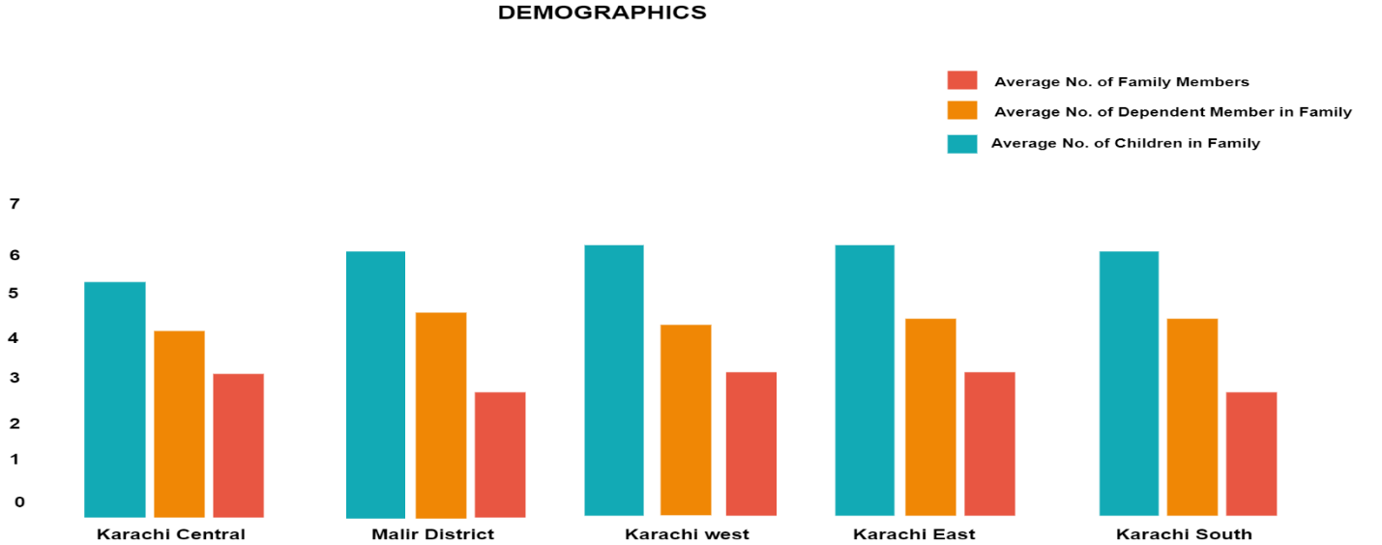

**Figure No.1** **Average Number of Family Members of Slums In Karachi**

The above figure shows the demographic comparisons of the number of family members, number of dependent members in the family, and number of children in the family, among all five districts of Karachi. The figure indicates that the average number of family members is highest in Karachi East district and lowest in Karachi Central district. It also shows that the dependency ratio is maximum in Karachi South and minimum in Karachi Central. The figure also demonstrates that the average number of children per family is highest in Karachi East district and lowest in Malir District.

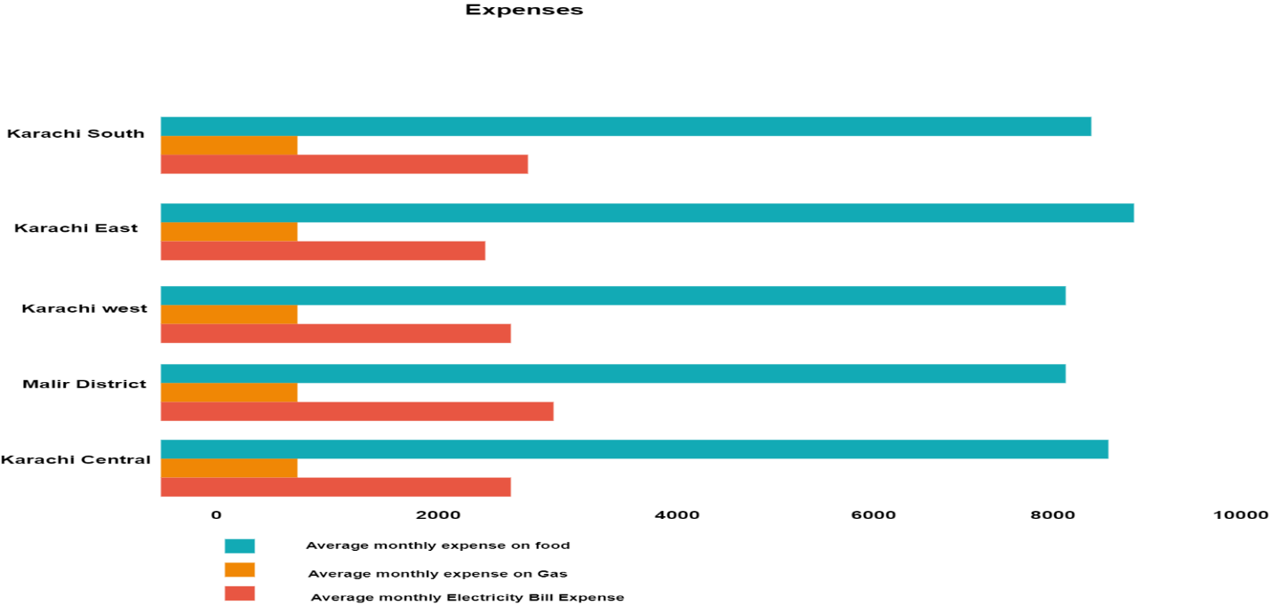

**Figure No. 2** **Household Expenses District Wise of Slums in Karachi**

The above Figure presents the comparisons of the expenses on food, electricity, and gas between the households of District Karachi Central, Malir District, District Karachi West, District Karachi East, and District Karachi South. The average monthly electricity bill expense in Malir district this expense is the highest among other districts while in Karachi East district it is the lowest. The average monthly expense on the gas bill is the maximum in Karachi Central district whereas, in Karachi West, it is the lowest. Figure 2 also indicates that food expenses are highest in Karachi East while it is lowest in Karachi West.

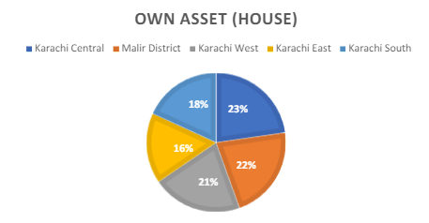

**Figure No. 3 House Ownership District Wise of Slums in Karachi**

In the figure 3 Pie Chart displayed the different percentages of the population that own asset (house) in all five districts of Karachi. From Figure 3 it can be easily evaluated that the highest percentage of the population own asset in District Karachi Central. While Karachi East has the lowest percentage of the population that owns asset.

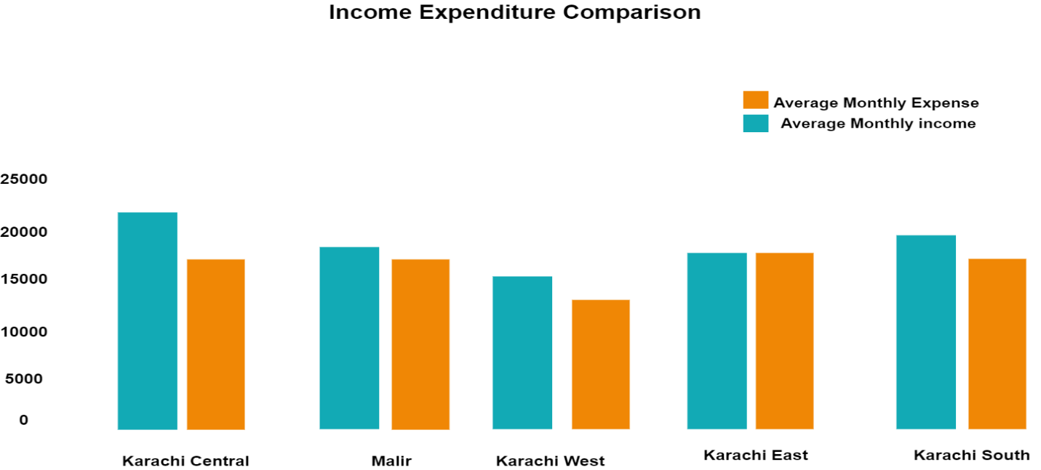

**Figure No. 3 Income Expenditure Comparison of Slums in Karachi**

It is obvious from Figure 4 that the average monthly expenses are highest in Karachi East and it is lowest in Karachi West. However, the average monthly income is highest in Karachi Central and lowest in Karachi West.

This is a self-administrated survey has been conducted on 375 households in eight, major slum areas in Karachi (Orangi Town, Manghopir, New Karachi, Surjani Town, Bangali Para Gulshan, Lyari, Malir, and Korangi)

1. **Orangi Town Slums Sectors:**

Here are some neighborhoods within Orangi Town that are commonly referred to as slum areas:

1. Mominabad
2. Qasba Colony
3. Ghaziabad
4. Baloch Goth
5. Banaras Colony
6. Miskeen Colony
7. Pirabad
8. **How to overcome each of the sector of slum area in Orangi, karachi?**
9. ***By using BOT / PPP Approach***
10. **Mominabad:** *Water Supply and Sanitation Services*

* Private companies could bid for contracts to build, operate, and transfer water supply and sanitation facilities in Mominabad.
* The government or a local authority could lease land for the infrastructure and provide regulatory oversight.
* The private entity would finance the construction, operation, and maintenance of the facilities in exchange for user fees or a share of revenue generated from water sales.
* After a specified period, ownership and operation of the facilities would transfer to the government or community, ensuring long-term sustainability.

1. **Qasba Colony:** *Housing Infrastructure Upgradation*

* Private developers could enter into partnerships with the government or local authorities to upgrade housing infrastructure in Qasba Colony.
* The private entity would finance, design, and construct housing units, leveraging their expertise and resources.
* Residents could access affordable housing through rent-to-own schemes or subsidized financing arrangements facilitated by the partnership.
* Once the housing units are completed and occupied, ownership could transfer to residents or a housing cooperative, with ongoing maintenance responsibilities shared between the community and private entity.

1. **Ghaziabad:** *Infrastructure Development and Community Services*

* A consortium of private investors, NGOs, and government agencies could form a PPP to invest in infrastructure development projects in Ghaziabad.
* The private consortium would finance, design, and implement infrastructure projects such as flood mitigation, drainage improvement, and street lighting.
* Revenue streams could include government grants, user fees for enhanced services, and returns on investment from infrastructure assets.
* The PPP agreement would specify performance targets, governance structures, and mechanisms for risk-sharing and dispute resolution.

1. **Baloch Goth:** *Land Regularization and Social Enterprise Development*

* The government or local authority could partner with private investors to regularize land tenure and support social enterprise development in Baloch Goth.
* Private investors could finance the regularization process and infrastructure upgrades in exchange for long-term land leases or revenue-sharing agreements.
* Social enterprises could be incubated and supported through a combination of grants, equity investments, and business development services provided by the partnership.
* The partnership agreement would outline the roles and responsibilities of each party, as well as mechanisms for monitoring and evaluating social and financial performance.

1. **Banaras Colony:** *Environmental Conservation and Green Energy Solutions*

* Private firms specializing in green technology and environmental services could partner with the government or local authorities to implement environmental conservation projects in Banaras Colony.
* The partnership could involve the development and operation of renewable energy systems, waste recycling facilities, and water conservation initiatives.
* Revenue streams could include government subsidies, sales of environmental products and services, and carbon credits.
* The partnership agreement would define project scope, financing arrangements, and mechanisms for revenue sharing and risk management.

1. **Miskeen Colony:** *Healthcare Access and Social Impact Investing*

* Private healthcare providers could enter into a PPP with the government or local authorities to deliver healthcare services in Miskeen Colony.
* The private entity would finance, build, and operate telemedicine clinics and healthcare kiosks, leveraging technology to reach underserved populations.
* Revenue streams could include user fees, insurance reimbursements, and government subsidies for targeted healthcare services.
* The PPP agreement would establish quality standards, service delivery targets, and mechanisms for cost-sharing and performance monitoring.

1. **Pirabad:** *Disaster Preparedness and Community Resilience*

* A coalition of private companies, NGOs, and government agencies could form a PPP to implement disaster preparedness and emergency response initiatives in Pirabad.
* The partnership could involve the training of community members in disaster preparedness, establishment of emergency shelters, and provision of emergency response services.
* Funding sources could include government grants, corporate donations, and user fees for emergency training and services.
* The PPP agreement would outline roles and responsibilities, funding mechanisms, and procedures for coordination and communication during emergencies.

**Sector-Specific Solutions Private Sector Partners**

**| |**

**+-----------+-----------+ |**

**| | |**

**Infrastructure Development Housing Upgradation Environmental Solutions**

**| | |**

**| +----------+----------+ |**

**| | | |**

**Water Supply & Health care Social Enterprise Disaster Preparedness**

**Sanitation Services Development & Community Resilience**

**| | | |**

**+------------+------------+--------+--------+**

**|**

**Financing & Investment**

**|**

**+---------+---------+**

**| |**

**Revenue Streams Performance Metrics**

**| |**

**+------------+-----------+ |**

**| | |**

**User Fees Government Grants, Social Impact Metrics**

**& Subsidies,**

**Service Charges, Private Investment,**

**Revenue Sharing Corporate Sponsorship**

**| |**

**+-------+--------+ |**

**| | Project Implementation,**

**Revenue Generation | Monitoring & Evaluation**

**& Profit Share | Mechanisms**

**Opportunities |**

**(for Private |**

**Sector Partners) |**

**|**

**Transfer of Ownership/Management**

**to Government/Community**

**References**

* Final copy of the survey in eight major slum areas in Karachi. <https://rmsjournal.com/index.php/admin/article/download/214/110>
* Karachi population according to district wise. <https://www.dawn.com/news/1750728#:~:text=Karachi%20division%20is%20administratively%20divided,%2C%20Malir%2C%20Korangi%20and%20Keamari>
* Developing country studies. Vol.7, No.11, 2017. Malir district Slum areas and other information. <https://www.iiste.org/Journals/index.php/DCS/article/download/39586/40706>